**School Absentee Surveillance System (SASS)**

SASS is an online absentee surveillance system. The system is optimized to process, analyze and display daily absentee data for a school district. The system not only displays absentee trends but also generates a range of different absentee warnings based on complex rules.

The solution consists of a district wide absentee dashboard as well as school-specific dashboards. The solution also consists of tools for uploading data files and downloading processed data. All data loaded into the system can be easily downloaded for additional processing.

The solution requires two sets of data to operate:

1. **A one-time upload** of school information for a district – an Excel file with the name, address, educational level of every school in the district
2. A **daily upload** of school absentee data for the district – Excel files with the absentee information for each school and classroom

The daily uploads of absentee data can be done manually or using an automated SFTP option.

**Example School Data (NOTE: detailed example files contain the full spec):**

**School** – Washington Elementary  
**Address1** – 123 Main Street  
**City** - Layton  
**State** - Utah  
**Zip** – 84040  
**Level** - Elementary  
**Phone** – (801)123-4567  
**Fax** – (801)765-4321

**Example School Absentee Data** **(NOTE: detailed example files contain the full spec):**

**CurrentDay**- June 4, 2015 **SchoolName** – Washington  
**GradeLevel** - 1  
**ClassName** – First Grade  
**Teacher** – K.D.  
**TotalEnrolled** - 23  
**TotalAbsent** - 2  
**TotalUnknown** - 1  
**TotalSick** - 1  
**Gastrointestinal** - 0  
**Repiratory** - 1  
**Rash** - 0  
**OtherIllness** - 0  
**UnknownIllness** - 0

**School District Daily Dashboard**  
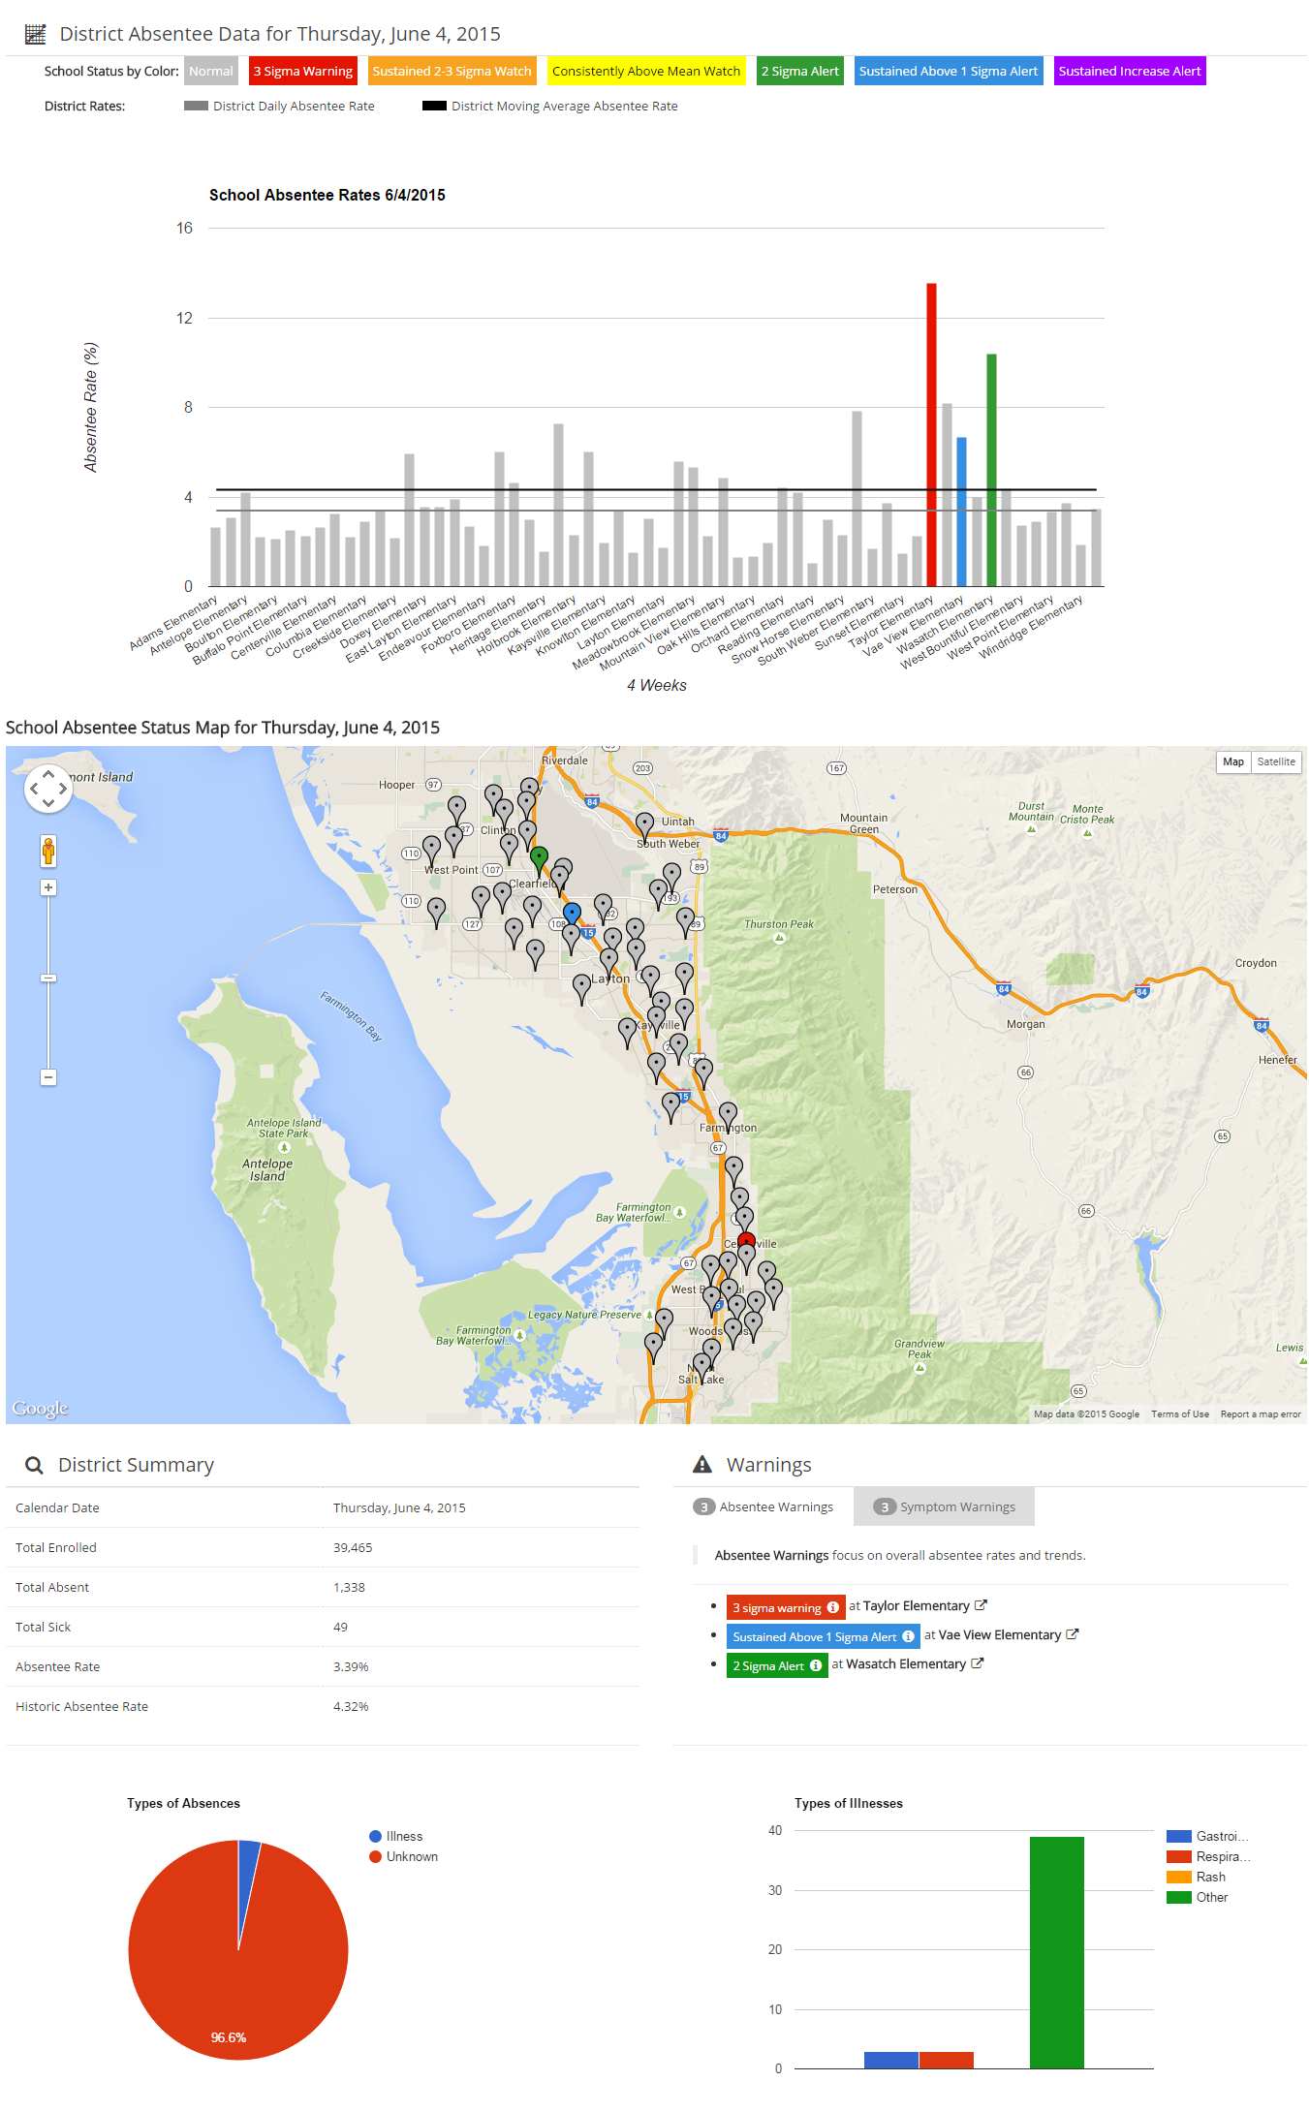

**School District Daily Dashboard (cont.)**

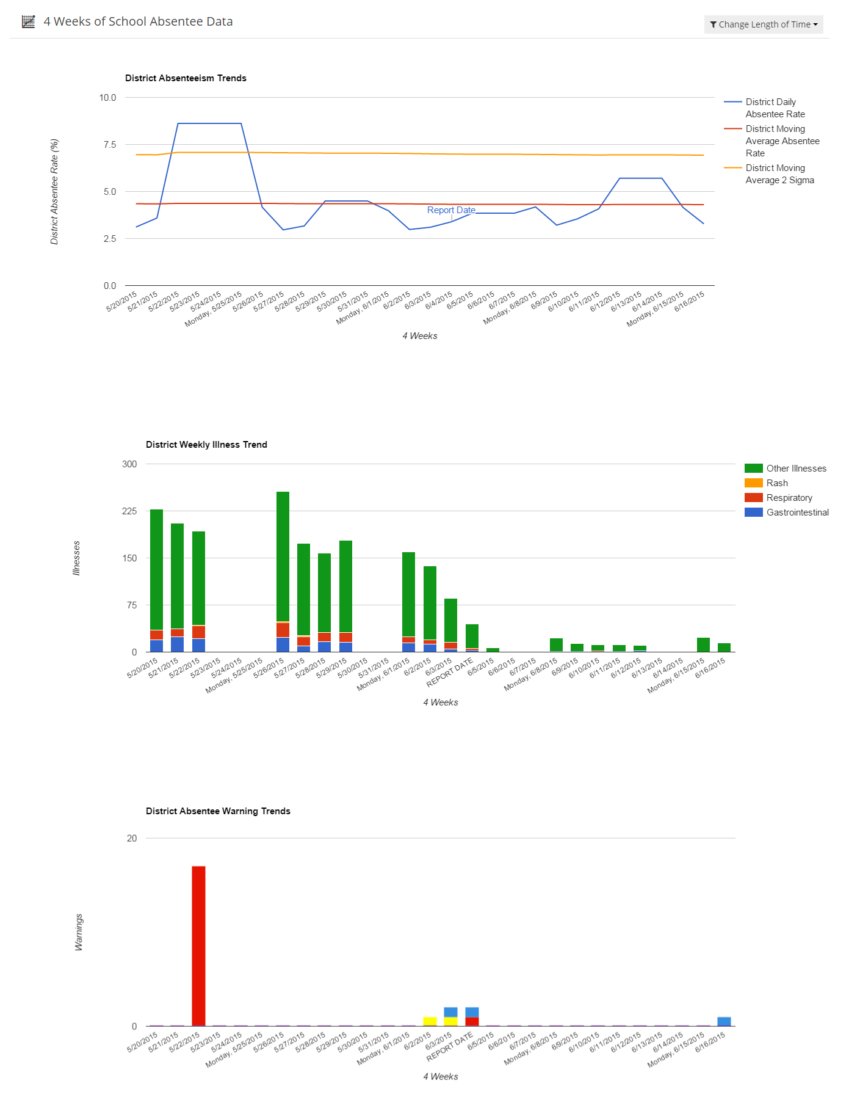

**Individual School Daily Dashboard**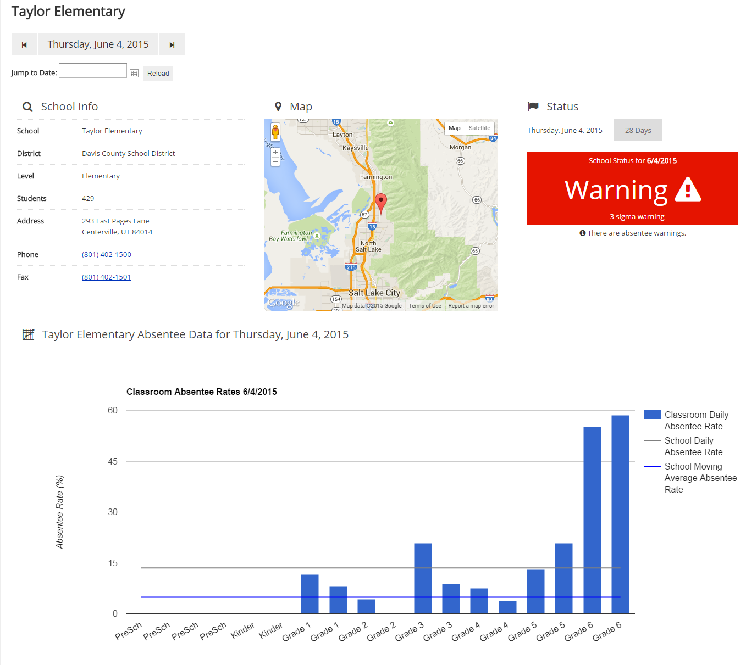

**School Daily Dashboard (cont.)**

